**18 JUNE:**

**Exercise:3**

Initially create a new project,package and class in eclipse to run a java code

To install jar files

Right click on the project

Click on—-build path—add external archives—hadoop3.2.1—Share

In share

1.Click on common—open hadoo—-common—-3.2.1.jar

2.Click on Mapreduce—-Open hadoop—-mapreduce—-Client—-core—-3.2.1.jar

Right click on project—Export—-Java—Jar file—Next

Browse the address of the java file and save it on desktop and named it .jar

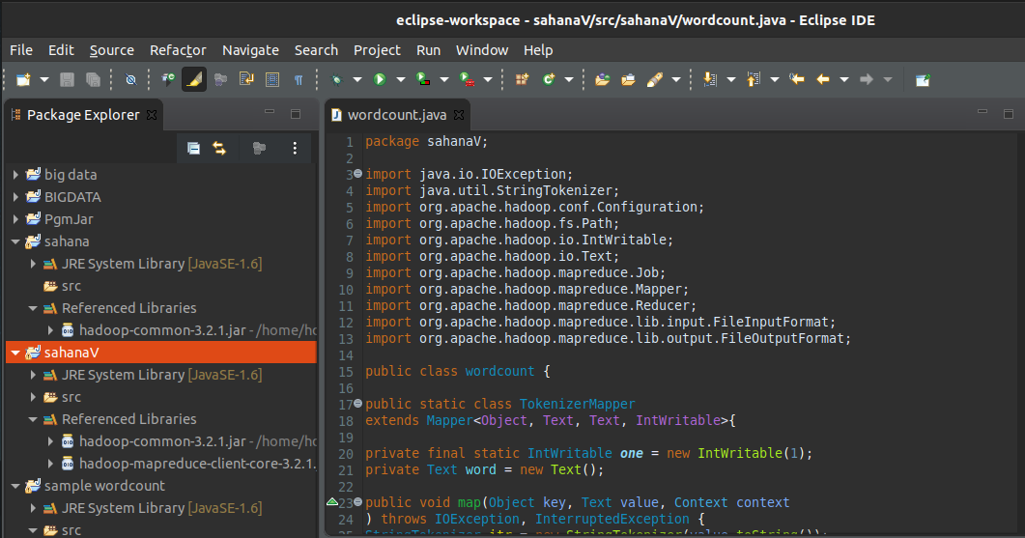

***In the terminal:***

***Run commands***

cd $HADOOP_HOME

cd sbin

start-all.sh

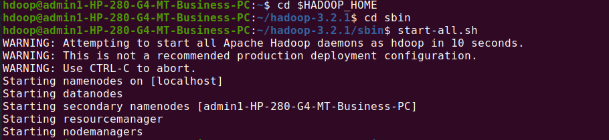

*hdfs dfs -mkdir -p ~ /sahanaV*

*hdfs dfs -appendToFile - ~/sahanaV/file.txt*



Hadoop jar /home/hdoop/Desktop/sahanav.jar ~/sahanaV ~/sana

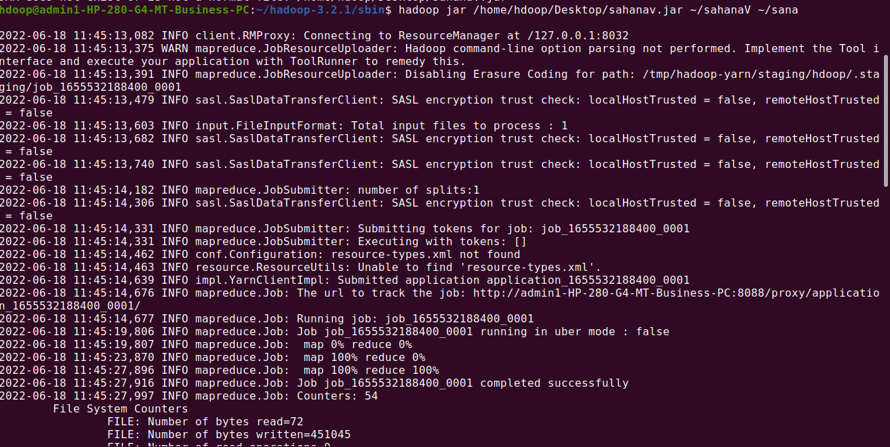

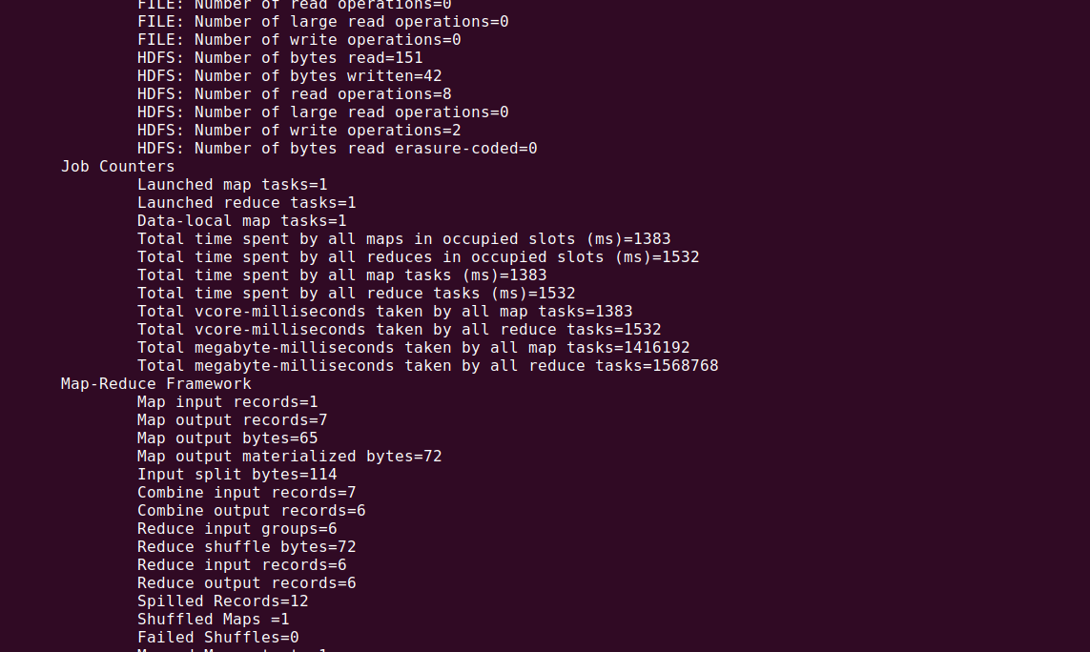

*hdfs dfs -cat ~/sana/part\**

